## 



## Goolwa Radio Yachting Group (GRYG) Membership Form

**Current membership is simply an expression of interest in the group. There are no fees at the moment until the group becomes a formal club We collect and store**

**Member information for contact, security and safety. All information is stored securely and only shared with other members of the group. Information is stored in database**

**along with an image of the member and yachts**

Family Name: Preferred Name: Given Names (all):

Address: City/Town/Suburb: State: Post Code:

Date of Birth:

Partner’s Name: Emergency Phone:

Home Phone: Mobile: E-mail:

Previous sailing experience:

Member of other Radio Yachting Club: (Club Name)

Note:

**Radio Yacht Information**

**Yacht type may be One Metre, RG95 etc. Indicate ‘Y’ or ‘N’ for whether the yacht is measured and Registration number**

|  |  |  |
| --- | --- | --- |
| Yacht Type | Sail Number | Measured/ Reg No |
|  |  |  |
|  |  |  |

**Please complete the form and return it to Ben Morris or Richard Gregg at the sailing venue by the Goolwa Regatta Yacht Club Monday or Friday 2-5pm or complete the on-line membership form on the club website at http://www.rcyachting.scoastmac.org.au by selecting the ‘Membership’ link from the top menu.**

**Sailing Venue**

The group sails in the Goolwa Regatta Yacht Club basin, inside the public jetty to the south. While this restricts us in terms of courses appropriate to wind direction, it is a relatively sheltered area which has proved beneficial to beginning radio sailors

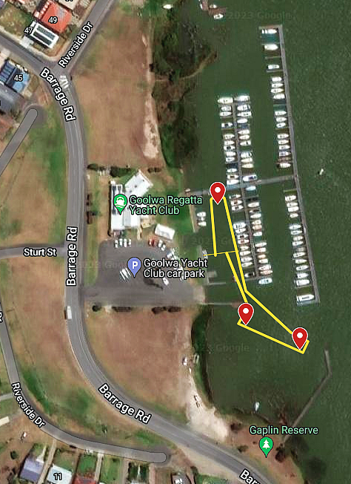

Sailing occurs from the channel in front of the car park towards the public jetty. Buoys are placed around the course. The start and finish line is within the channel by the car park.

**Goolwa Radio Yachting Group**

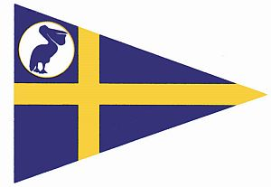

**About our group:**

The Goolwa Radio Yachting Group (GRYG) meets every Monday and Friday from 2:00 pm. to 4:30 pm at the Goolwa Regatta Yacht Club basin, weather permitting. The group was initially based on sailing a ‘Phantom’ yacht. Most sailors now sail the International One Metre (IOM) a world class radio yacht.

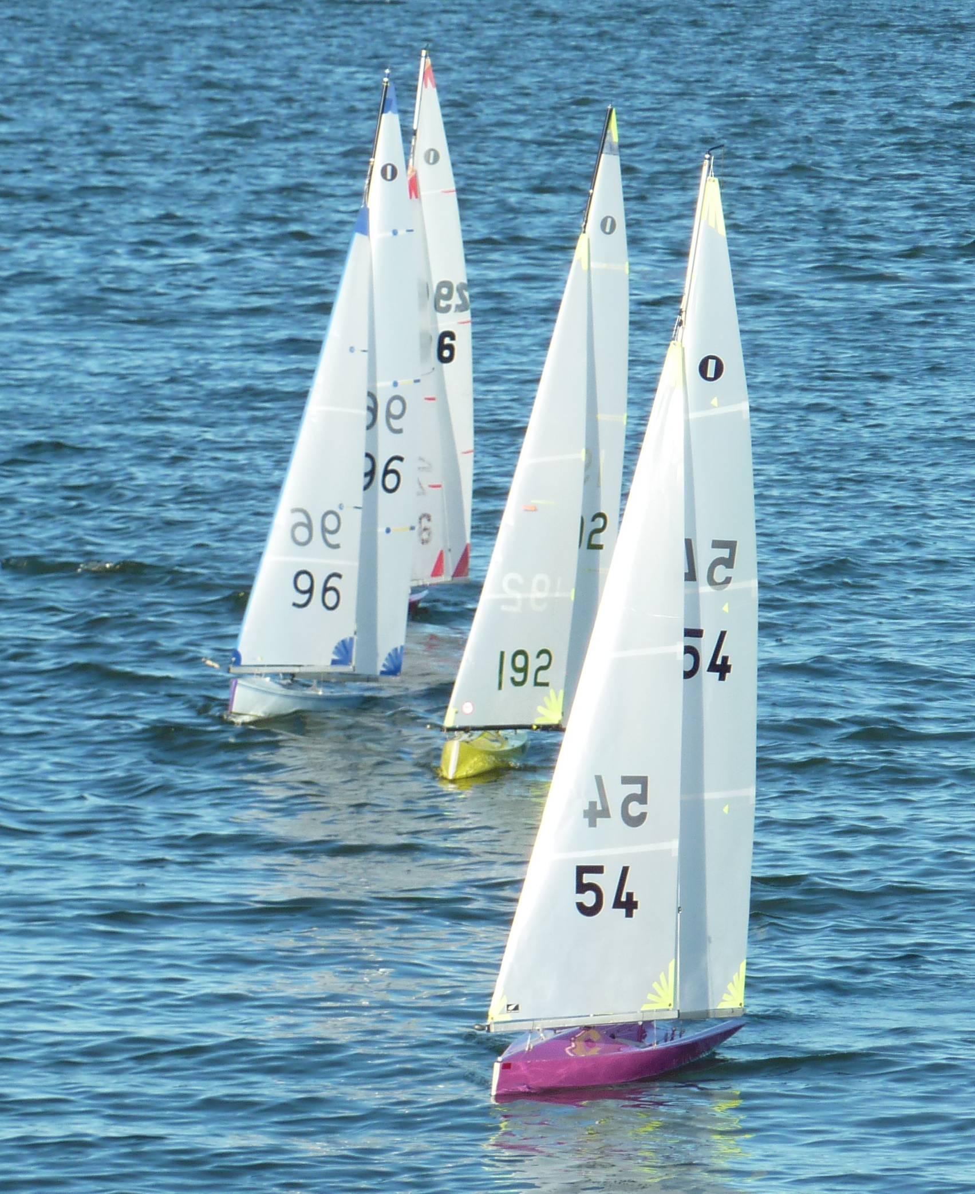

There is considerable information on the website about modifying Phantoms, but it is a lot of work and they are not built strongly. Some of our members occasionally still sail their Phantom. There are newer designs which are still relatively cheap such as the DF95 which do sail quite well and are built more solidly than the Phantom.

We encourage IOMs as the yacht of choice though we will accept most radio yachts. Very large (greater than 1 metre) or heavy ones can be a problem in retrieval and potential damage to other boats so come and talk to us first. IOM yachts have three rigs and are very exciting yachts, able to sail in winds to 30 knots or more (without breaking!)

The group races every Monday and Friday. Racing begins at 2:30 pm and we are very fortunate to have a regular PRO – Phil- who keeps us all in check. All races are handicap with timed staggered starts. This is to encourage all sailors with a range of experience (and yacht) to all compete with a chance of success.

There is no joining fee associated with the GRYG at this stage, but we do collect member details for contact and safety reasons. Goolwa Regatta Yacht Club supports the radio sailing group in many ways and we encourage all our participants to consider becoming members of that club.

**Contact details:**

Ben Morris:

Mob: 0424364428

E-mail: benmorris@senet.com.au

Richard Gregg

Mob: 0408655763

E-mail: rdgregg1@bigpond.com

Web Site: http://www.rcyachting.scoastmac.org.au

Goolwa Regatta Yacht Club: Ph: 08 8555 2617